Thermal Joining
  - Key Revision Facts: GCSE Technology

Thermal Joining requires heat to join materials.

Name | Applications | Image | Where used | Why use
Soldering – Soft soldering is a method of joining metals with a Tin/Lead Alloy. The heat sources are often a Soldering Iron. | Soldering is commonly used in electronics | 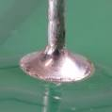 | Circuit boards | It conducts electricity
Brazing – Brazing is a metal joining process in which two or more metal items are joined together by melting and flowing a filler material into the joint. The filler metal will have a lower melting point than the adjoining metal. | Metal pipes and tubes | 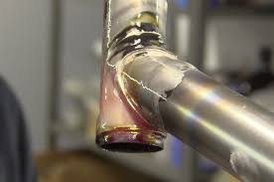 | Water pipes | can join dissimilar metals
Welding – Welding uses two gasses to create lots of heat to melt the two surfaces that cause a gap that is a field with a flux core to seal the gap. | Steel frame | 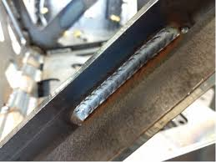 | Car frames | It creates a strong bond between two metals

Download
More Key Fact Revision sheets can be downloaded from
www.andrew-seaford.co.uk/revision

Version information
Date | Arthur | Comment
13-Mar-2021 | Andrew Seaford | Initial release.

